Logging Using SLF4J

1.Logging error messages and warning levels

LoggingExample.java
import org.slf4j.Logger;
import org.slf4j.LoggerFactory;

public class LoggingExample {

private static final Logger logger = LoggerFactory.getLogger(LoggingExample.class);

public static void main(String[] args) {

logger.error("This is an error message");
logger.warn("This is a warning message");
}
}

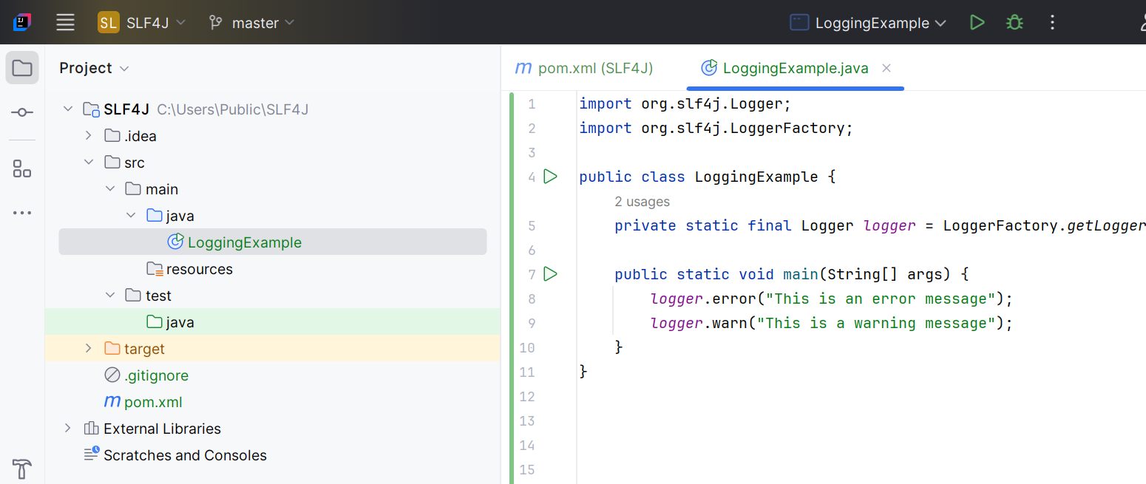

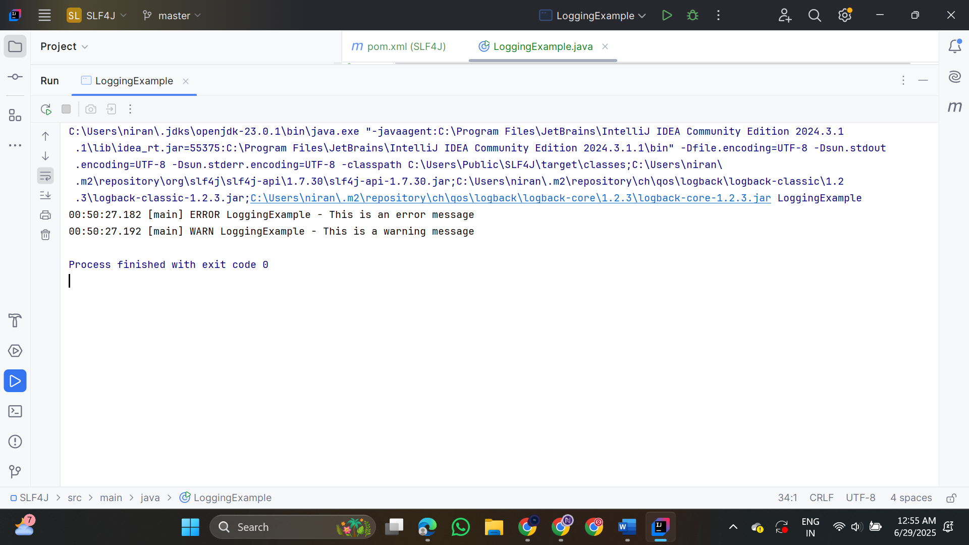

2. Parameterized Logging

LoggingParameterizedExample.java

import org.slf4j.Logger;
import org.slf4j.LoggerFactory;
public class LoggingParameterizedExample {
private static final Logger logger = LoggerFactory.getLogger(LoggingParameterizedExample.class);
public static void main(String[] args) {
String username = "ruba";
int items = 5;
double price = 12.99;
logger.info("User {} added {} items to cart. Total price = {}", username, items, price);
int errorCode = 404;
String page = "/products/unknown";
logger.error("Error code {} occurred while accessing {}", errorCode, page);
}
}
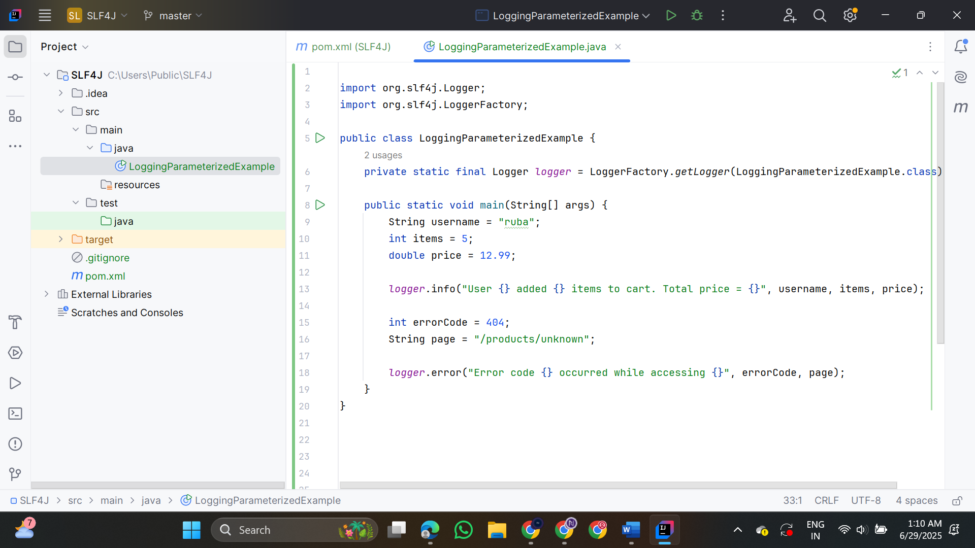

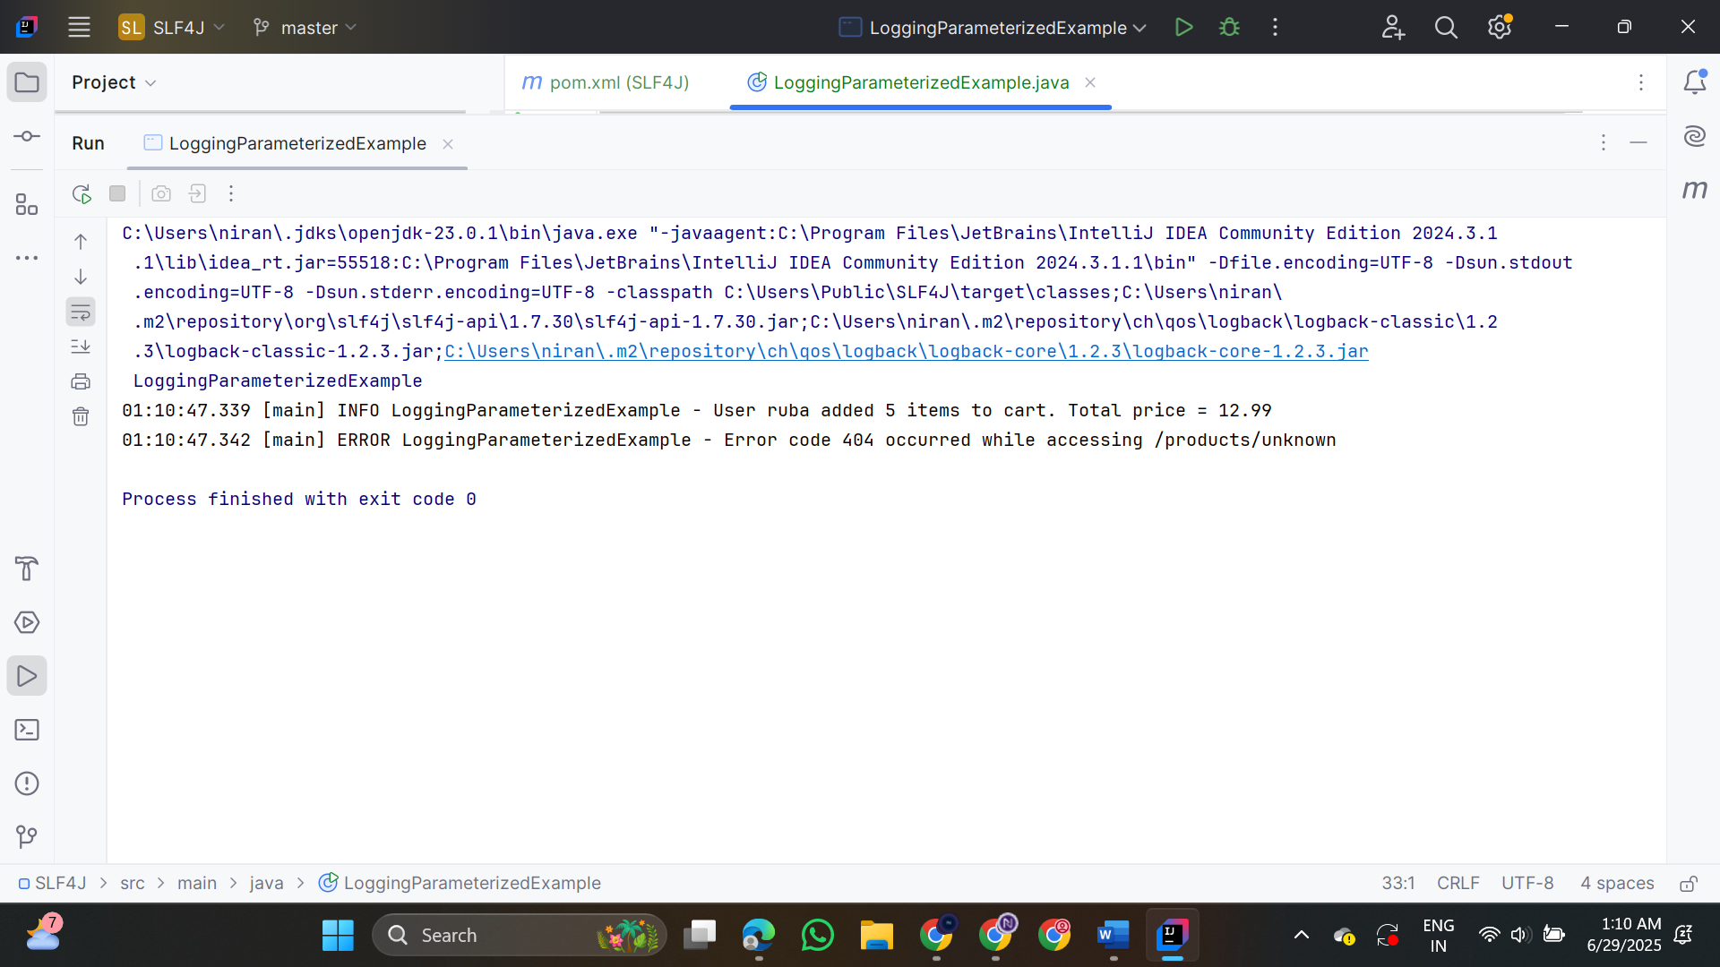

3. Using Different Appenders

LoggingWithAppenders.java
import org.slf4j.Logger;
import org.slf4j.LoggerFactory;

public class LoggingWithAppenders {

private static final Logger logger = LoggerFactory.getLogger(LoggingWithAppenders.class);

public static void main(String[] args) {

logger.info("This is an info message");
logger.debug("This is a debug message");
logger.warn("This is a warning message");
logger.error("This is an error message");
}
}

